**Create New Users in Windows 10**

1. Locate the Microsoft Management Console by typing “mmc” into the Windows search bar, then the **enter key** to open it:

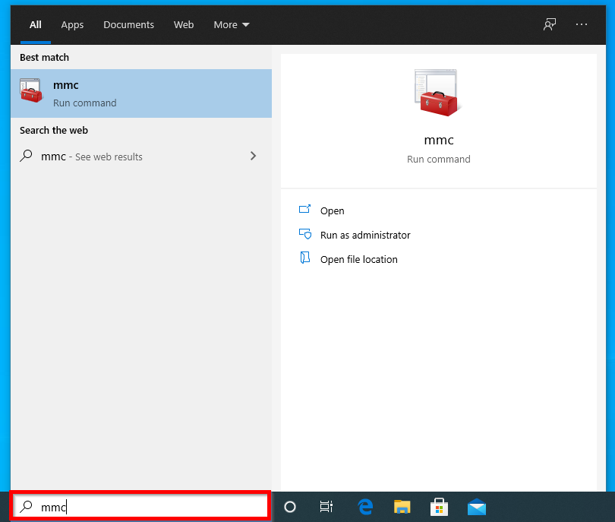

1. When the “User Account Control” window pops up, click **Yes**:

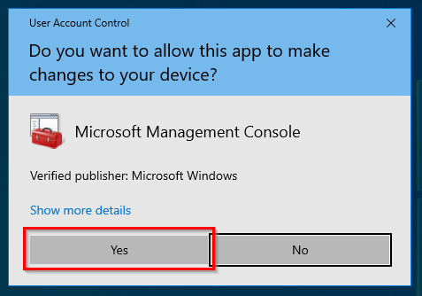

1. In the new console window that opens, click **File** in the left-hand corner then **Add/Remove Snap-in…**

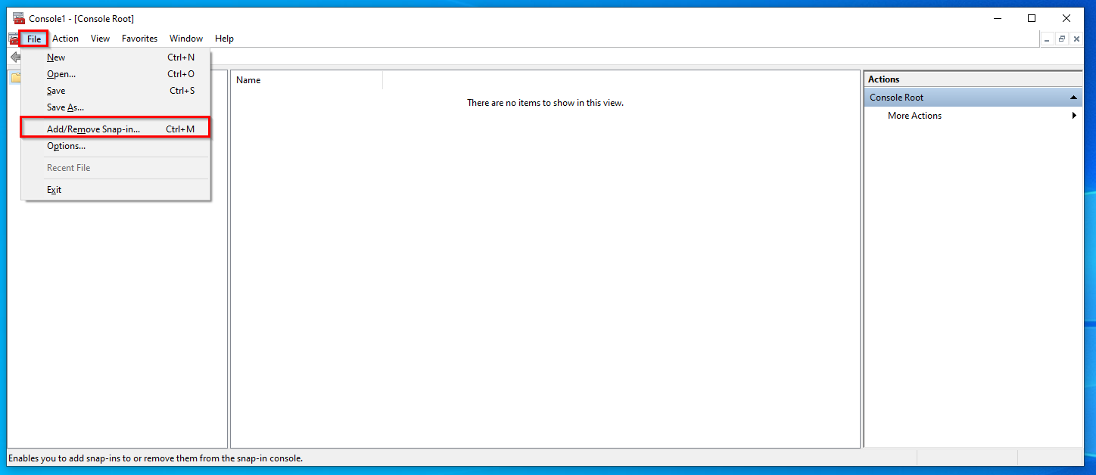

1. In list-box on the left-hand side of this new window, locate the **Local Users and Groups** Snap-in using the scrollbar. Double-click on it:

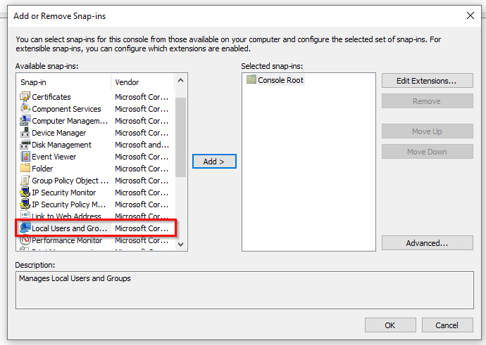

1. In the new window titled “Choose Target Machine”, click **Finish**. The “Local Users and Groups” snap-in will now appear in the box to the right. Click on **OK**:

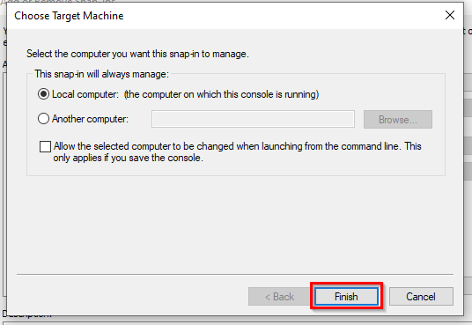

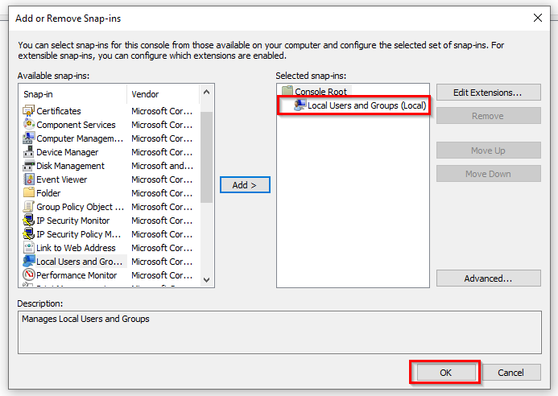

1. Back in the console window, double-click **Local Users and Groups (Local)** to reveal the Users file. Double click on the **Users** file:

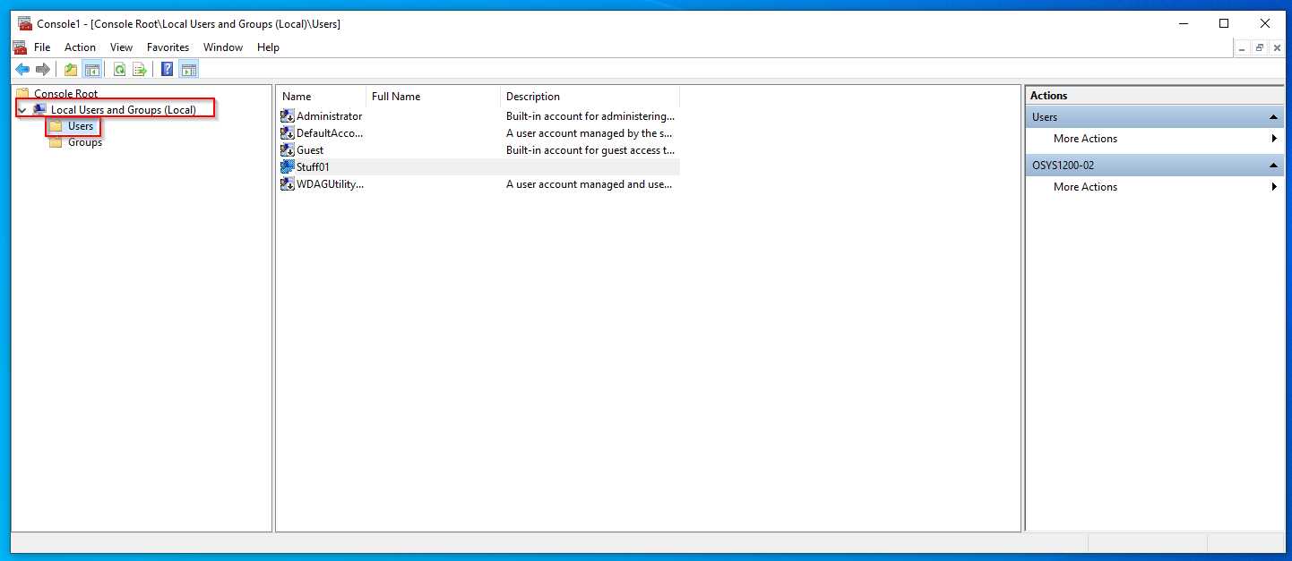

1. Right-click anywhere within the blank space of the middle section of the window, then click **New User…**

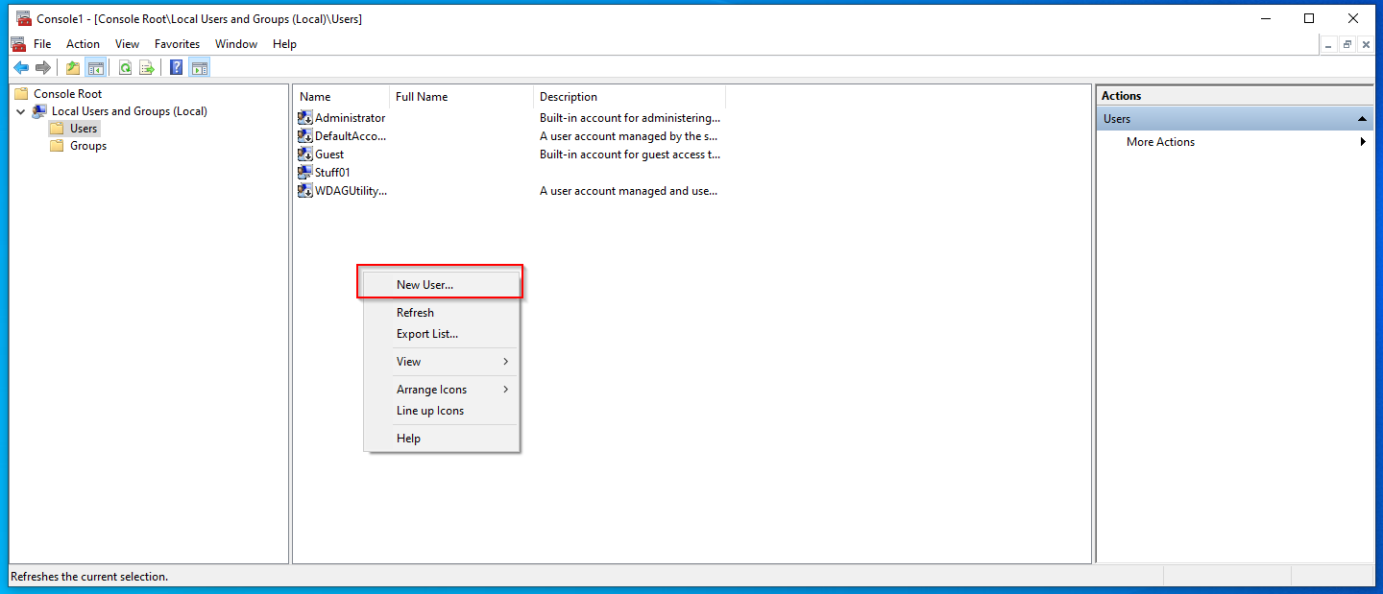

1. In the “New User” window that opens, enter the desired information into the appropriate fields. In this case, a new account is created for a user named “Wanda”. Click **Create** when finished:

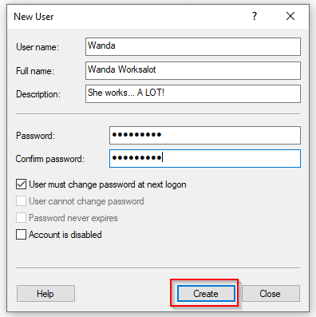

1. Repeat **step 8** for any additional new users. In this case, two more users are created: Ramona and Duncan. Click **Close** once all new users have been created:

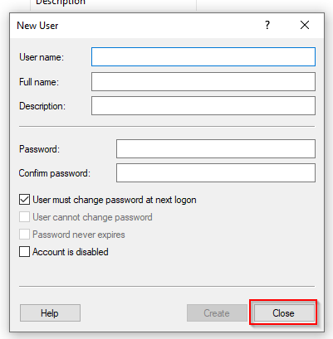

1. Wanda, Duncan, and Ramona now appear in the list of users on device Stuff01:

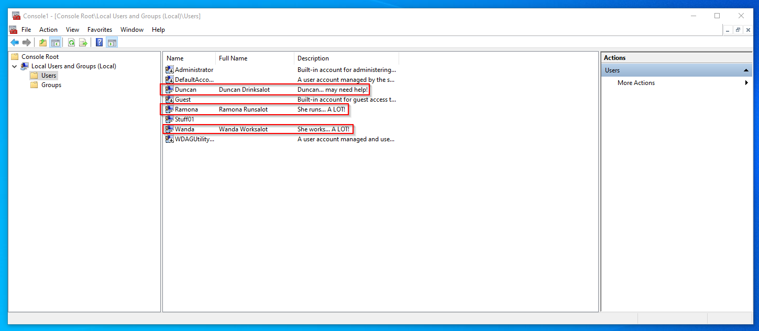

1. Create a shortcut to this console by clicking **File**, then **Save As…**:

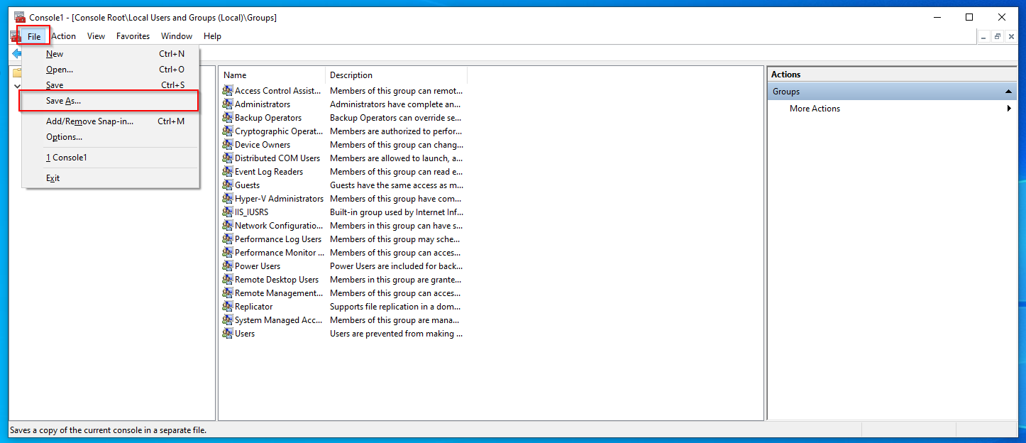

1. In the new window, select “**Desktop**” from the drop-down menu to the right of “Save in:”, enter a name for the console in the textbox to the right of “File name:”, then click **Save**:

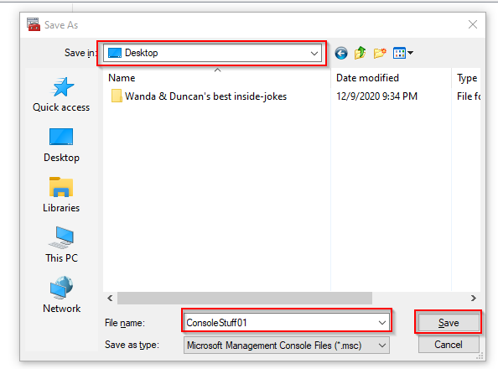

1. Repeat **steps 1-12** on device “Stuff02” for three new users: Barry, Doreen, and Dave:

